Wits University Faculty of Science post-graduate student AI declaration
I understand that the use of generative AI tools (such as ChatGPT or similar) without explicitly declaring such use constitutes a form of plagiarism and is classified by Wits University as academic misconduct.
I declare that in the course of conducting the research towards my degree or in the preparation of this thesis/dissertation/research report (select one by marking with an X):

I did not make use of generative AI tools
[X] I did make use of generative AI tools for the following (tick all that apply):
- Idea Generation (research problem/design, hypothesis)
X
- Sourcing Related Work (summarising, identifying sources)
X
X
- Methods and Experiment Design (experiment setup, model tuning)
- Data Analysis (presentation, coding, interpretation)
X
- Theoretical Development (theorem proving, conceptual analysis)

- Code Development (generating algorithms, writing scripts)
X
- Presentation (rendering graphics, formatting)
X
- Editing (grammar, readability)
X
- Writing (text generation, document structuring)
X
- Citation Formatting (structuring, organising)
X

If other uses were involved, please specify below:
Generative AI tool used (list all) | Used for?
ChatGPT (OpenAI) | Early supervision and planning: experiment ideas, decision rules and reviewing results.
Claude (Anthropic) | Supervision: planning experiments, decision rules, reviewing results against saved outputs, drafting and editing the report.
Claude Code (Anthropic) | Writing, testing and running analysis code and cluster jobs.
OpenAI Codex | Code review, commits and report editing and checking.

If generative AI tools were used as an integral part of the experimental design or in the direct execution of my research, I confirm that details of this use are clearly outlined in the relevant experimental/methodology chapters of my thesis/dissertation/research report.
Student number: 2653934

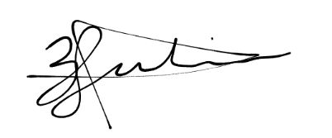
Candidate signature:

Date: 30 October 2026
Relevant prompts
The full record of AI instructions and decisions is kept in the project's supervision log.
Curated prompts: [to be added by Zayd]

